**MyPunter Website App Dev - 6**

1. Add a login page, once the use logs in, the system will remember the user and user doesn’t need to login again like “WeChat”.

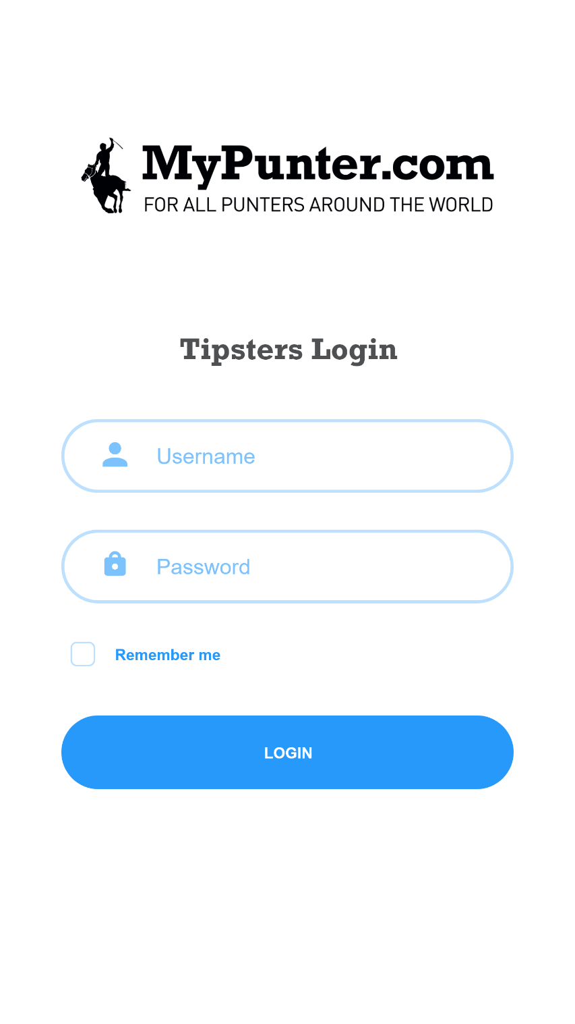

1. Add a splash screen like the one in the old Mypunter App.

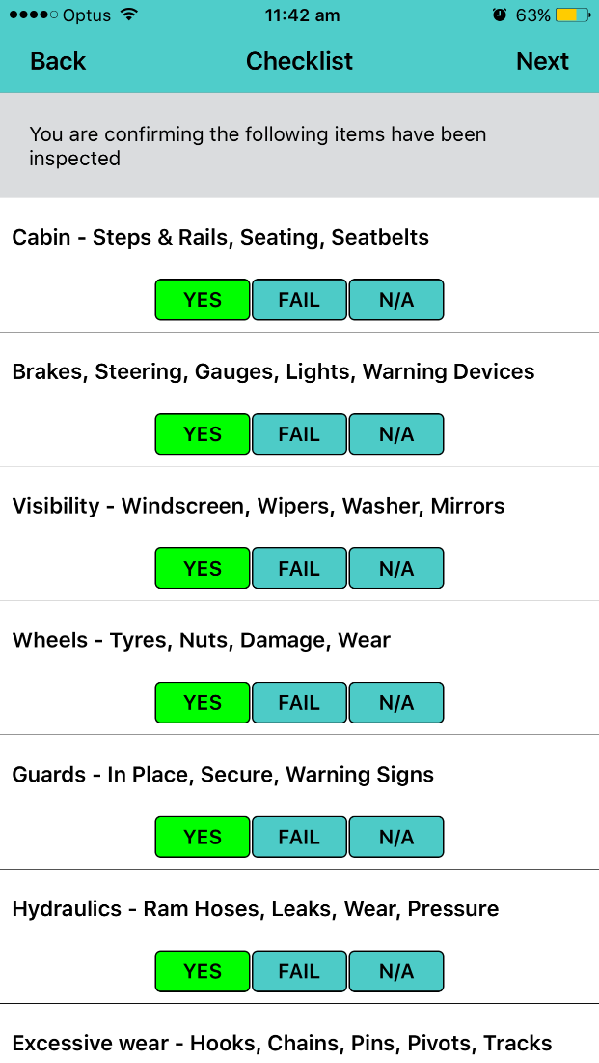

**MyPunter.com**

**For all Punters around the World**

1. In the “Track Details” page, the last input “How many races?”, if you enter 3, then in the next page there would be only 3 races: R1, R2, R3, if you enter 4, then there would be 4 races. And the auto filling button is for auto setting the time for R2, R3, R4… after setting the time for R1, for example, user could set auto filling for every 30 min first and then set the time for R1, then time for R2, R3… is automatically set, or user set R1 time first, then set every 30min, then time for R2, R3… is automatically set. Also, the time span between two races could be 27min or 25min or 18min, so don’t just set the time span to 1h, 2h or 3h, make it accurate to minute.
2. In “Races” page, the “Require selections legend?” part. There is a rule of how does this work with the color systems:
3. First of all, there are several options for selections legend to choose. You can only choose from the list below, like “Double Up”, “Special”, “Best Bet”… . So make the input field for selections legend a dropdown selection list not manually input. And each selection legend has a unique color, this color will be showing in the tip result worksheet

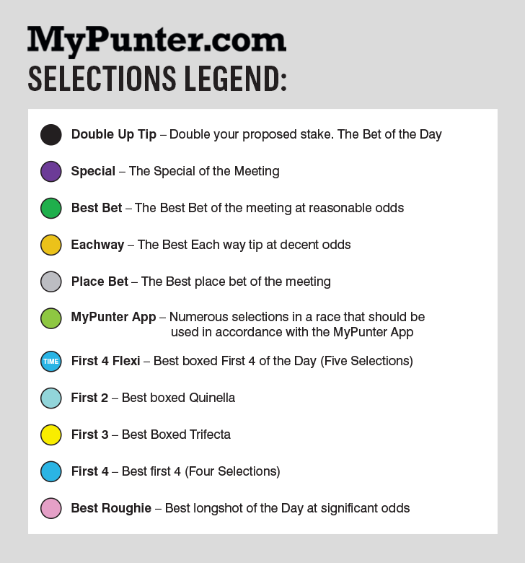

1. Here is an example of the tip result in worksheet generated by the data user input, and I’ll show you where all the input data go in this sheet:

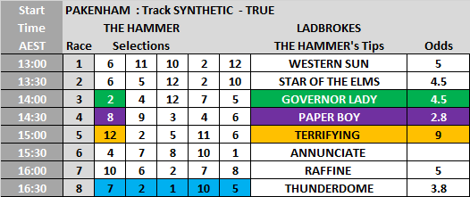c) different color represents different selections legend in different races, the row without color means no need of selections legend for that race. Take the above as example, in Race 3, the row is covered by color green, means our tipster selected “Best Bet” as selections legend. Race 4 is colored purple means “Special” as selections legend for race 4. And Race 5 has “Eachway” as its selections legend. Race 8 has color blue covering all its five selections, so the selections legend is “First 4 Flexi”. So this is how the data interacts with the generated worksheet.

**selections**

**odds**

**Name**

**Race time**

**How many races**

**Rail**

**Track Condition**

**Meetings**

**Affiliates**

**Tipster’s name**